Software Development 3

Assignment 1

CIT185753

Kitman Yiu

The game I goanna make will be a word base game, there will be two player’s the server will send some word to the client and they both type and the one types the fastest will when win and go to the next round they will have 1:00 and the highest score will be the winner, also the game will have a high system which the data will save to the database, an image is showed below the idea

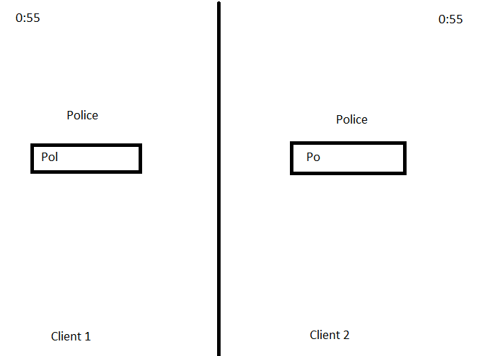

Since I have experience of HTML , CSS , PHP and my SQL so I’m not to worry consider about this part this is one of the website [www.kitmanyiu.com](http://www.kitmanyiu.com) that I created and hosted on goDaddy by the above languages ,The part that I’m worry about is MVP since I haven’t learn about it and it will change the whole structure of my coding and also the tools the communicate between server and client. But to able the achieve the goal I decided to use ASP.net MVP4, since I have maybe we have a full time job I would need to found some tutor to teach me asp.net MVP4 because it will save me more time to go in errors , I decided choice to use ASP.net is because by the following reason:

* ASP.NET makes development simpler and easier to maintain with an event-driven, server-side programming model.
* No limited script languages
* Allows developers to build very compelling applications by making use of Visual Studio,
* With built-in Windows authentication and per-application configuration, your applications are safe and secured
* It provides better performance by taking advantage of early binding, just-in-time compilation, native optimization, and caching services right out of the box
* It is purely server-side technology so, ASP.NET code executes on the server before it is sent to the browser.
* ASP.NET makes for easy deployment. There is no need to register components because the configuration information is built-in.
* Easily works with ADO.NET using data-binding and page formatting features. It is an application which runs faster and counters large volumes of users without having performance problems

This is one of the project that I have been created to learn ASP.net:

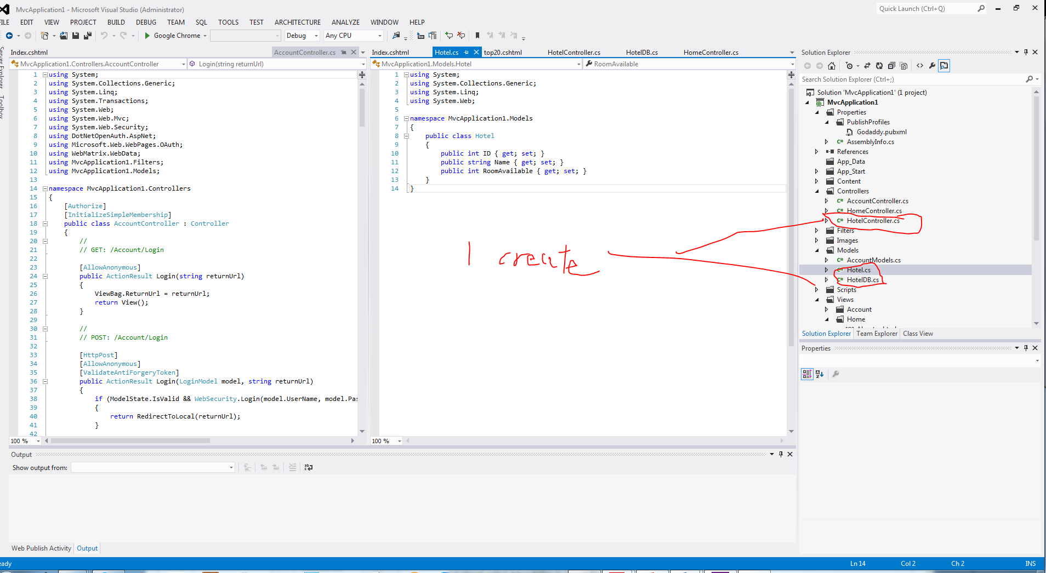

The following class/files that the game will maybe have for the end of the project:

Server.cs

Client.cs

Index.php

SeverDB.cs

The following is basic timetable for my learning process:

Week 12/3/2015 learn how to create a server and then send a message to the client

Week 19/3/2015 learn how to send a message back to server

Week 23/3/2015 create a sample of my game without using any server and client

Week 1/4/2015 Adding a server and client to my game , and do a checkpoint and check what to do next .